***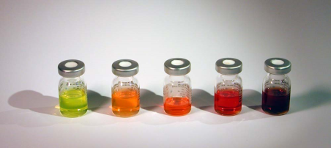******ISSYP***

Quantum Dots

In this activity you will observe particles (electrons) behaving like waves. Classical particles can have a continuous range of energies. Electrons are observed to have discrete energy values so they must not be classical particles. Quantum dots are nano-scale semiconductors that fluoresce when stimulated by light. The colour of the fluorescence depends on the size of the quantum dots. To understand this phenomenon we will treat the electrons in the quantum dots like waves trapped in a box.

**Wave-in-a-box**

An ideal classical particle (with mass $m$ and energy $E$) confined to a box of length $L$ will bounce between the two fixed walls with an energy, $E=\frac{1}{2}mv^{2}=\frac{p^{2}}{2m}$. At any instant of time it must be moving either to the right *or* to the left with a magnitude of momentum, $p= ±\sqrt{2mE}$.

According to de Broglie, the electron is a particle that *behaves like a wave*, with wavelength $λ=h/p$. A wave moving to the right inside the box reflects off the wall, creating a wave moving to the left, and vice versa. The box is thus filled with waves moving in both directions simultaneously. For an electron to behave like this wave, it must *be* in many places at once (wherever the wave is nonzero), and also be *moving* both to the right *and* to the left at the same time!

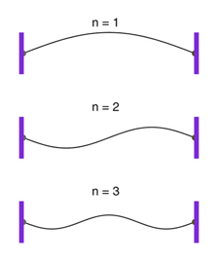

Such waves reflecting back and forth inside a box of length $L$ will cancel out unless the wavelength has certain special values: $λ={2L}/n$, where $n=1,2,3,…$ (see diagram). In this case we get self-reinforcing “standing wave” patterns. Re-arranging the formula $λ=h/p$ and substituting into the equation $E=p^{2}/2m$, we find that the electron in the box can have only certain discrete values of energy:



$$E_{n}=\frac{h^{2}n^{2}}{8mL^{2}}, n=1,2,3,…$$

Observe that the lowest possible energy, $E_{1}= {h^{2}}/{8mL^{2}}$, *increases* as the box gets smaller. Quantum particles are “claustrophobic”: they gain a weird “quantum confinement” energy when they are confined to a small area.

**Semiconductors and Quantum Dots**

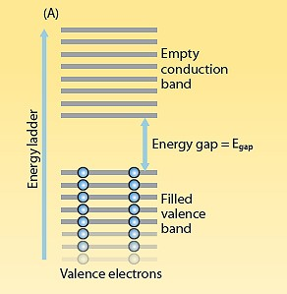In a semiconductor the energy levels of adjacent atoms merge into bands. An electron in a semiconductor will either be in the low energy *valence band* or the higher energy *conduction band*. These energy bands are separated by a *band gap energy*, $E_{BG}$, where electrons cannot exist.

Our quantum dots are made of a semiconductor with $E_{BG}=2.15x{10}^{-19} J$. When we shine light from the blue LED onto a quantum dot, an electron in the valence band absorbs a photon of this light and jumps into the conduction band. It quickly drops back down to valence band, emitting a photon of energy ${E=E}_{BG}$. The colour (i.e., frequency) of this fluorescent light reveals the band gap energy through $E=hf$. But this is not the whole story…

Because the quantum dots are so small, the band gap energy is *increased* by the “quantum confinement” energy:

$${E_{BG,dot}=E}_{BG}+\frac{h^{2}}{8m^{*}R^{2}}$$

where $m^{*}=6.43x{10}^{-32}$ kg is a certain “effective mass” of the electron in the semiconductor, and $R$ is the radius of the quantum dot, which we can think of roughly as a box of length $L=R$. (Compare the last term in the above equation with the previous formula, $E_{1}= {h^{2}}/{8mL^{2}}$.)

The frequency of fluorescent light is equal to the band gap energy which depends on $R$, the size of the quantum dot. In other words, the colour of the fluorescent light is a direct result of the quantum confinement effect, which happens because the electrons in the quantum dots are particles behaving like waves!

**Instructions**

1. Illuminate the yellow paper with the red LED and then the blue LED. *What do you observe?*

2. Illuminate each vial with the red LED. *What do you observe?*

3. Illuminate each vial with the blue LED. *What do you observe?*

**Observations**

The following peak wavelengths of fluorescent light were recorded for the vials using a digital spectrometer when illuminated by the blue LED:



|  |  |  |  |  |
| --- | --- | --- | --- | --- |
|  | Vial#1 | Vial#2 | Vial#3 | Vial#4 |
| Wavelength (nm) | 540 | 570 | 600 | 630 |

**Analysis**

1. What can you infer about blue light compared to red light based on the behaviour of the yellow paper?

2. Which vial do you think has the largest particles? Explain.

3. The formula at the top of the previous page can be rearranged to solve for $R$:



where: $h$ is Planck’s constant ( $h = 6.626 ×{10}^{-34}$ Js)

$f$ is the frequency of light emitted

$R$ is the radius of the quantum dot

Use this formula to calculate the size of the particles in Vial#1 and Vial#4. Do your results agree with your prediction in problem 2 above?

**Thinking Deeper**

1. When filling a bottle with tap water a sound is produced. As the water level increases so does the pitch of the sound. Why?

2. Each vial contains quantum dots made from the same semiconductor material (indium phosphide). The same blue LED is used to stimulate the vials. The only difference in each case is the size of the dots that are suspended in the liquid. Why does the size of the dot affect the colour of fluorescence?

3. The red LED does not cause fluorescence. What does this imply about the size of the dots?